**BX2174: RESEARCH AND DECISION MAKING FOR BUSINESS**

ASSESSMENT TASK 3 COLLEGE OF BUSINESS, LAW AND GOVERNANCE



**INDIVIDUAL TASK COVER SHEET**

|  |  |  |  |  |  |  |  |  |  |
| --- | --- | --- | --- | --- | --- | --- | --- | --- | --- |
| *Student*  *Please sign, date and attach cover sheet to front of assessment task for all hard copy submissions* | | | | | | | | | |
| **SUBJECT CODE** | BX2174 | | | | | | | | |
| **STUDENT FAMILY NAME** | **Student Given Name** | **JCU Student Number** | | | | | | | |
| Tran | Le Binh | 1 | 3 | 4 | 7 | 6 | 1 | 1 | 2 |
| **ASSESSMENT TITLE** | Research Proposal | | | | | | | | |
| **DUE DATE** | 25/05/2018 | | | | | | | | |
| **LECTURER NAME** | Sven Dahms | | | | | | | | |
| **TUTOR NAME** | Sven Dahms | | | | | | | | |
| **Student Declaration**   1. This assignment is my original work and no part has been copied/ reproduced from any other person’s work or from any other source, except where acknowledgement has been made (see *Learning, Teaching and Assessment Policy 5.1*). 2. This work has not been submitted for any other course/subject (see *Learning, Teaching and Assessment Policy 5.9*). 3. This assignment has not been written for me. 4. I hold a copy of this assignment and can produce a copy if requested. 5. This work may be used for the purposes of moderation and identifying plagiarism. 6. I give permission for a copy of this marked assignment to be retained by the College for benchmarking and course review and accreditation purposes.   [Learning, Teaching and Assessment Policy](http://www.jcu.edu.au/policy/allitoz/JCU_076643.html) 5.1. A student who submits work containing plagiarised material for assessment will be subject to the provisions of the [Student Academic Misconduct Requirements.](http://www.jcu.edu.au/policy/allitoz/JCUDEV_005375.html)  **Note definition of plagiarism and self plagiarism in Learning, Teaching and Assessment Policy:**  **Plagiarism:** reproduction without acknowledgement of another person’s words, work or expressed thoughts from any source. The definition of words, works and thoughts includes such representations as diagrams, drawings, sketches, pictures, objects, text, lecture hand-outs, artistic works and other such expressions of ideas, but hereafter the term ‘work’ is used to embrace all of these. Plagiarism comprises not only direct copying of aspects of another person’s work but also the reproduction, even if slightly rewritten or adapted, of someone else’s ideas. In both cases, someone else’s work is presented as the student’s own. Under the Australian *Copyright Act 1968* a copyright owner can take legal action in the courts against a party who has infringed their copyright.  **Self Plagiarism:** the use of one’s own previously assessed material being resubmitted without acknowledgement or citing of the original.  **Student Signature**  Tran Le Binh **Submission date** 25/ 05/ 2018 | | | | | | | | | |

**TABLE OF CONTENT**

**1. Analyzing the Business Decision or Problem 3**

**2. The Overall Research Design – Evaluating Options 3**

**3. What are the Key Variables and How Will You Measure Them? 4**

**4. Sample Requirements & Sampling Options 5**

**5. Ethical Issues 6**

# **Analyzing the Business Decision or Problem**

Tourism has been increasing dramatically in Singapore. In 2017, Singapore welcomed about 17.4 million of visitors all over the world (Tay, 2018). Therefore, it pushes the development of hospitality industry in terms of accommodation, recreation, food and beverage (Madison, 2018). To satisfy these demands when the visitors travel Singapore, it requires a high demand of human capital in hospitality sector to meet tourists’ needs. Especially, the Front Office position plays a vital role in the innovation of Tourism and Hospitality industry. Due to the fact that the Front Office staffs are people that generate the first impression and final contacting channel between clients and service providers and their position is normally situated at the entrance of the hotels. (The Importance of Front Office in Tourism and Hospitality Industry, n.d).

There are several responsibilities of Front Office staffs. Firstly, they must create the first positive impression by possessing professional appearance such as warm voice, sincerity, confidence and enthusiastic manner. Secondly, they should become good listeners and efficient communicators to deal with the customers’ concerns. Thirdly, they must be willing to solve the customers’ complaints by never expressing defensive, empathy the clients’ feelings and taking effective actions (Role of Front Office in The Hotel Industry Tourism Essay, 2015).

The above analysis illustrates the fact that the Front Office is an indispensable position regarding nurturing brand awareness and increasing reputation for the hotels. The employment for this position also poses a major concern from the perspectives of employers. Therefore, what are the criteria for recruiting the Front Office staffs to meet the labor demand in the increasing development of hospitality industry in Singapore?

# The Overall Research Design – Evaluating Options

This research will utilize qualitative data to examine the research question – What are the criteria for recruiting the Front Office staffs to meet the labor demand in the increasing development of hospitality industry? Qualitative data is collected from job advertisement on some websites like Josbtreet, Indeed, hotel websites, where the criteria are provided in the current recruitment needs. The impossibility of using quantitative data is that there are unavailable resources, the meaningless analysis from the information. The utilization of job advertisements brings about the reliability of information through the virtual employment advertisements in the labor market, which strengthens the research accuracy, persuasion, validity, meaningfulness. Furthermore, the research cannot conduct the questionnaires due to time consuming, unapproachable the practical managers to answer the questionnaires. Therefore, the strategy of collecting data is the netnography approach through the straightforward accessibility of websites such as Jobstreet, Indeed, hotels’ advertisements, the reduction costs in printing questionnaires and documents when conducting the research.

From these qualitative data, the method of report is the categories of meanings by classifying the information into 5 themes in regards to Experience, Language, Education, Working attitude and Skills. The importance of creating themes is to make the research simplify by comparison, interpretation, reduction in irrelevant information, emphasis on outstanding requirements in each theme. If it does not have the appearance of themes, the research will become chaotic, less stress the noticeable requirements from the need of labor demand.

The approach method is applying the deductive approach to substantiate the research question through observing and interpreting the gathered data (Saunders et al, 2016). The research does not use the inductive approach because it stems from the stages of observation initially, which leads to the biased conclusion of the research question. The research philosophy is the ontology. There is a fact that Front Office position is a white-collar occupation rather than the casual labor. Hence, they are able to make professional contacting point and positive impression between customers who are the local people and the tourists.

# What are the Key Variables and How Will You Measure Them?

The research applies the descriptive theory to comprehend the specific criteria to recruit the Front Office staffs in the labor market by collecting secondary data from Jobstreet, Indeed, hotels’ advertisements. After analyzing data, the research creates 5 variables regarding Experience, Language, Education, Working attitude and Skills. When referencing several job advertisements, there is a list of requirements from employer’s perspectives. Generating 5 variables makes the research process straightforwardly identify the basic requirements for the Front Office position.

The Experience variable is created to stress that the applicants should have the basic knowledge in hospitality areas, which is stored through the internship and previous working experience. This can influence their future behaviors and thinking when they work in new working environment. Normally, the minimum working experience ranges from 1 to 2 years. The Language variable is created to test the ability of communication in written or speaking in order to interact with clients and colleagues and report especial incidents to the managers when it is required. The statistic points out that English and Chinese are the most common languages. The Skills variable is created to show that the applicants must possess potential skills to work and deal with challenges in work such as communication, teamwork, interpersonal, supervisory, customer service, computer.

The Education variable is created to prove that the candidates experienced the process of training, learning in colleges or universities to gain the knowledge and they own the certificate in the hospitality industry or the candidates at least completed the secondary school. The education qualification includes the O/N level, the Diploma or Bachelor degree. The Working attitude variable is created to assess the way the applicants think and treat with customers when they are working and also reflect the professional operation in the hospitality industry. The working attitude includes being charming and internationally minded, positive working attitude, approachable and confident, responsible for work.

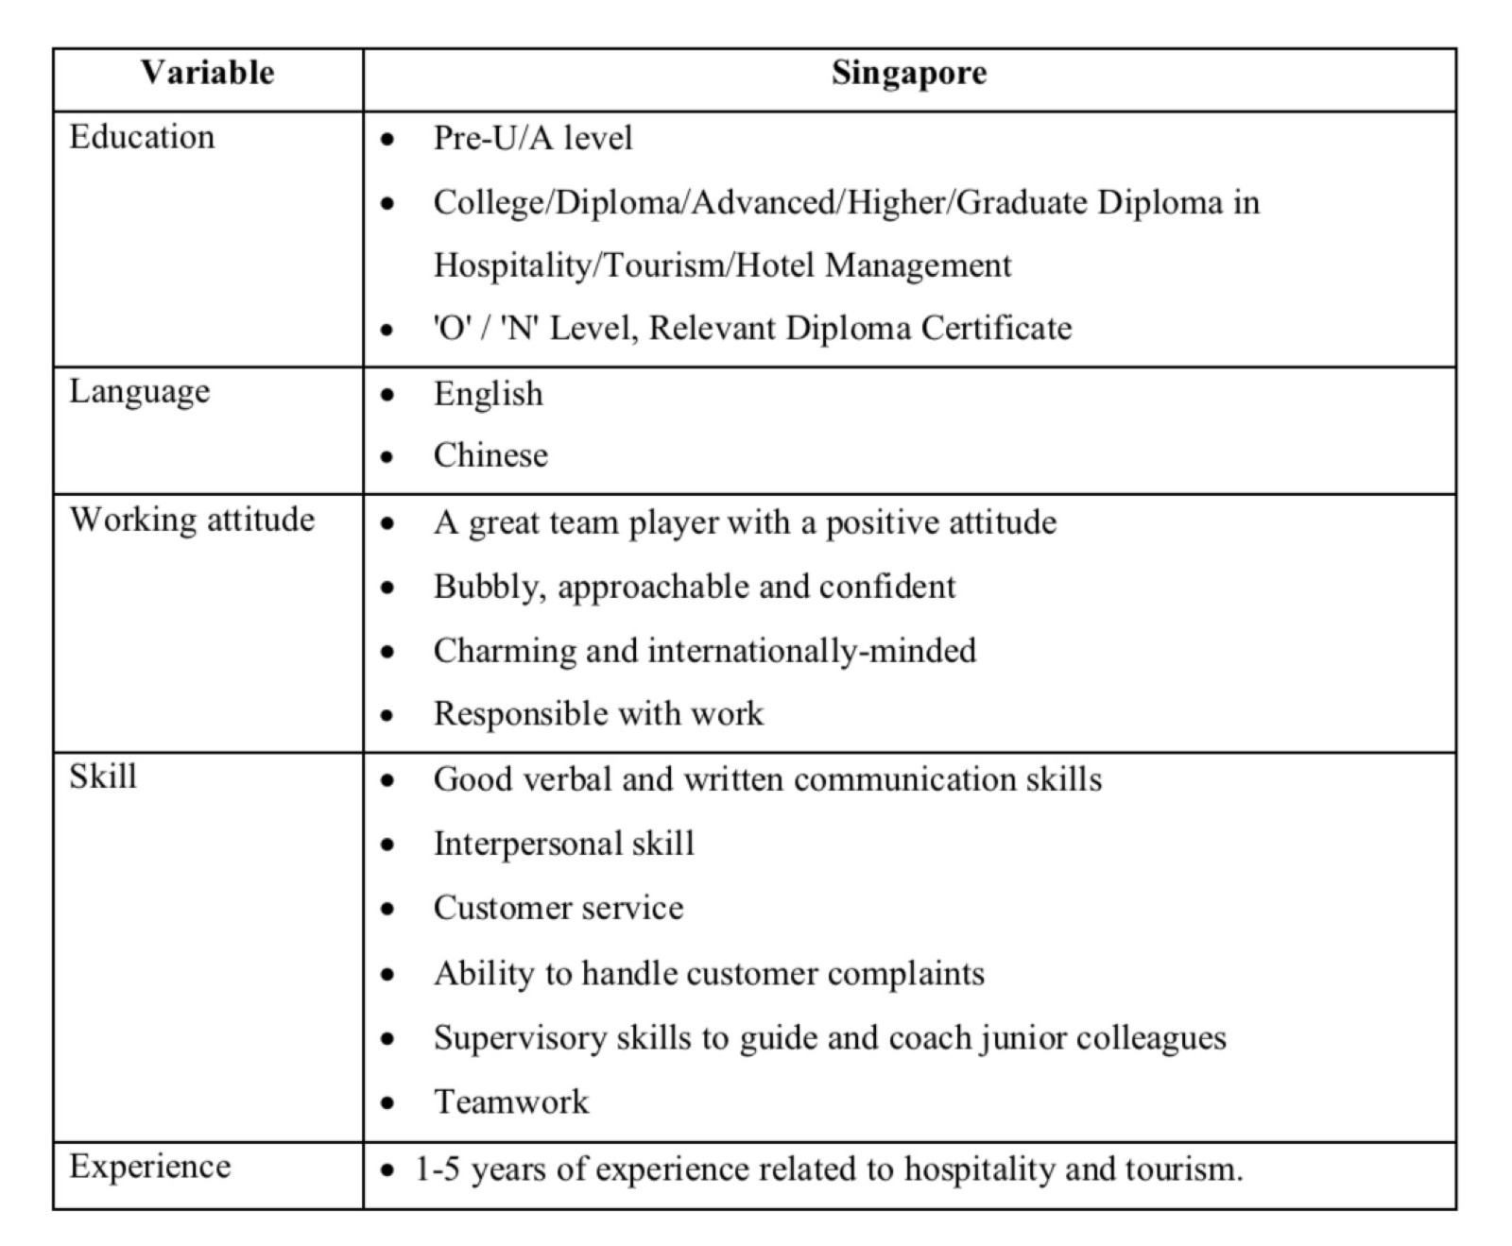

# Sample Requirements & Sampling Options

It will be impracticable if the research gathers job advertisements around the world in the hospitality industry. Therefore, the research focuses on 420 hotels which is from 3 to 5 stars’ hotels in Singapore (Singapore Tourism Board, 2018). Based on this proposed sampling, the research continues to search the job advertisement in order to find out the criteria for employing the Front Office staffs.

There are several job advertisements about the Front Office position on Jobstreet, Indeed, hotels’ advertisements. Firstly, the research just chooses the hotels from 3 to 5 stars’. The research does not choose the hotels which range from 1 to 2 stars because there is a minority of job advertisements for this sector. Generally, the Front Office staffs will undertake some tasks like checking in, checking out, bellboy and chambermaid. For that reason, some job advertisements from 1 to 2 stars’ hotels contain inappropriate requirements and there is process of choosing the unsuitable samples. Secondly, the research concentrates on 100 noticeable job advertisements. If the research selects more than 100 job advertisement, the information will be useless because there is some information that comes from the family businesses. The family businesses do not well establish the organization hierarchy so that the employment process as well as the interview is not professional.

During the phase of gathering sample, the research faces up to a major disadvantage. The research conducts in off-peak season so that there does not have a lot of job advertisements and the employment demand is not potential. Normally, the recruiters encounter the labor shortage before Chinese New Year (Singapore Business Review, 2014). Therefore, the research outcome is partly inaccurate.

The template for job advertisement comprises the responsibilities and the requirements. Beside the responsibilities, the requirements are the most concerning elements. First and foremost, it is Education. Any job advertisements always require the academic level, leading to become the prerequisite for employability in each company. Then, it is the Experience to express that how the working experience they are and whether they are competent or excellent. Next, it is the Attitude to reflect that whether the applicants are well-disciplined or not. This is also crucial to maintain the corporate image.

# Ethical Issues

Firstly, the research uses the jobs advertisements to predict and conclude the noticeable criteria for employing the Front Office staffs. Therefore, it results in the issue of authenticity. The research does not provide the official documents to the hotels so as to discover the current recruitment demand. There do not have practical employers to participate in the research. To address this issue, there should have a conservation with practical employers to comprehend their demands. Moreover, they will provide more information from their experiences. Hence, the research will further investigate to conclude the difference between the previous and present employment.

Secondly, there is an issue of consent. The research utilizes the available information on the Internet without the hotels’ consent. The hotels’ managers lack of acknowledgement when using the job advertisements for the research purpose. To combat this issue, the researcher must offer the letter to request the agreement from the managers, which creates the mutual benefits for both party and enhances the report accuracy.

Thirdly, there is an issue of privacy. The research results must be kept confidentially. Although the research utilizes the resources from the Internet, there should protect the data source carefully by the refusing of providing data source to the third party. The research does not allow to indicate the specific hotel brand to highlight the basic requirements. Because each enterprise requests distinctive criteria to employ their staffs in order to maintain the competitive advantage in the labor market. Revealing the hotel brand information will deteriorate the research reliability.

**REFERENCES**

Madison, E. (2018). Hospitality Industry in Singapore. Retrieved from <https://study.com/academy/lesson/hospitality-industry-in-singapore.html>

Role of Front Office in The Hotel Industry Tourism Essay. (2015). Retrieved from <https://www.ukessays.com/essays/tourism/role-of-front-office-in-the-hotel-industry-tourism-essay.php>

Saunders, M., Lewis, P., & Thornhill, A. (2016). *Research methods for business students*. Harlow, Essex, England: Pearson Education Limited.

Singapore Business Review. (2014). *Why Yearend Is THE Best Time to Find a Job in Singapore*. Retrieved from <https://sbr.com.sg/hr-education/commentary/why-yearend-best-time-find-job-in-singapore>

Singapore Tourism Board. (2018). *As The Sector Champion for The Hotel Industry, STB Focuses On Industry Development, Capability Enhancement, And The Regulation of Hotels in Singapore.* Retrieved from:

<https://www.stb.gov.sg/industries/hotels>

Tay, F. (2018). *Tourist Arrivals, Spending in Singapore Hit Record High for 2nd Straight Year; China Top Source of Visitors*. Retrieved from <https://www.straitstimes.com/singapore/tourist-spending-in-singapore-hit-record-268b-in-2017-china-top-source-of-visitors>

The Importance of Front Office in Tourism and Hospitality Industry. (n.d.). Retrieved from <http://www.mywestford.com/the-importance-of-front-office-in-tourism-and-hospitality-industry/>